Before run experiment
YARN ResourceManager UI (http://localhost:8088)
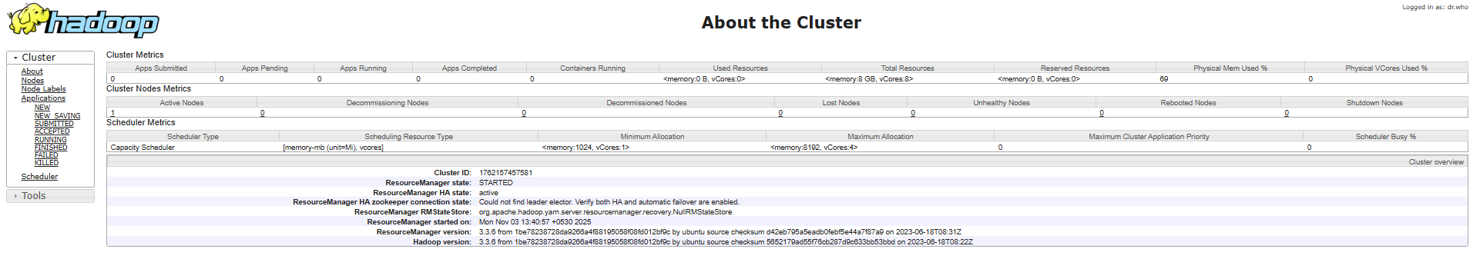
Cluster Info

Running/completed applications
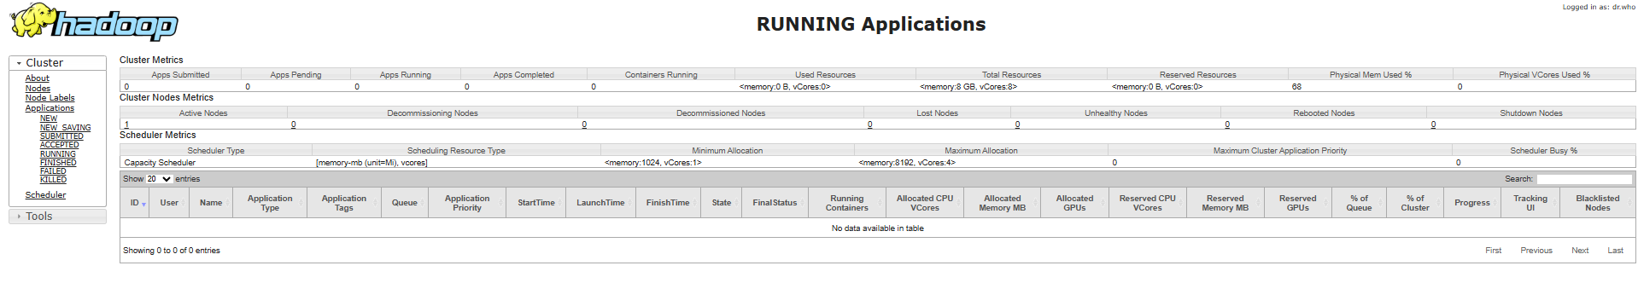
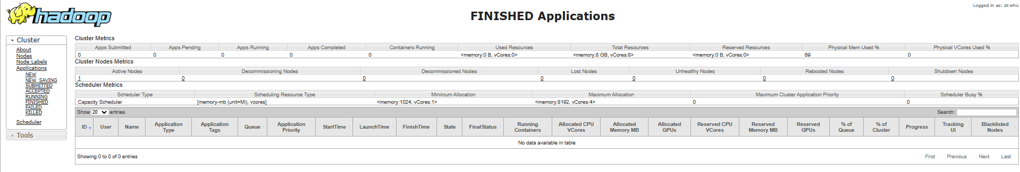
Job History Server UI (http://localhost:19888)
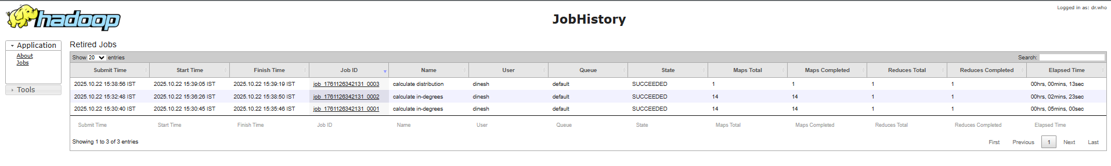
HDFS NameNode UI (http://localhost:9870)
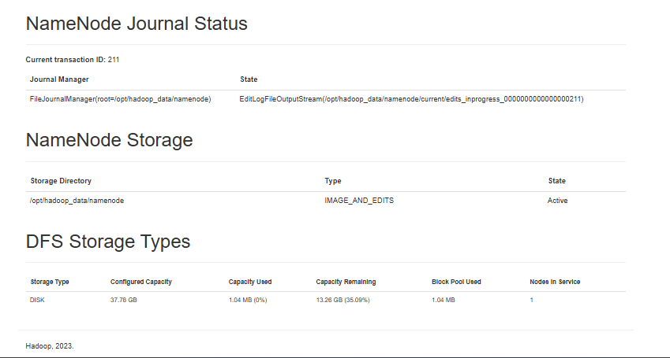
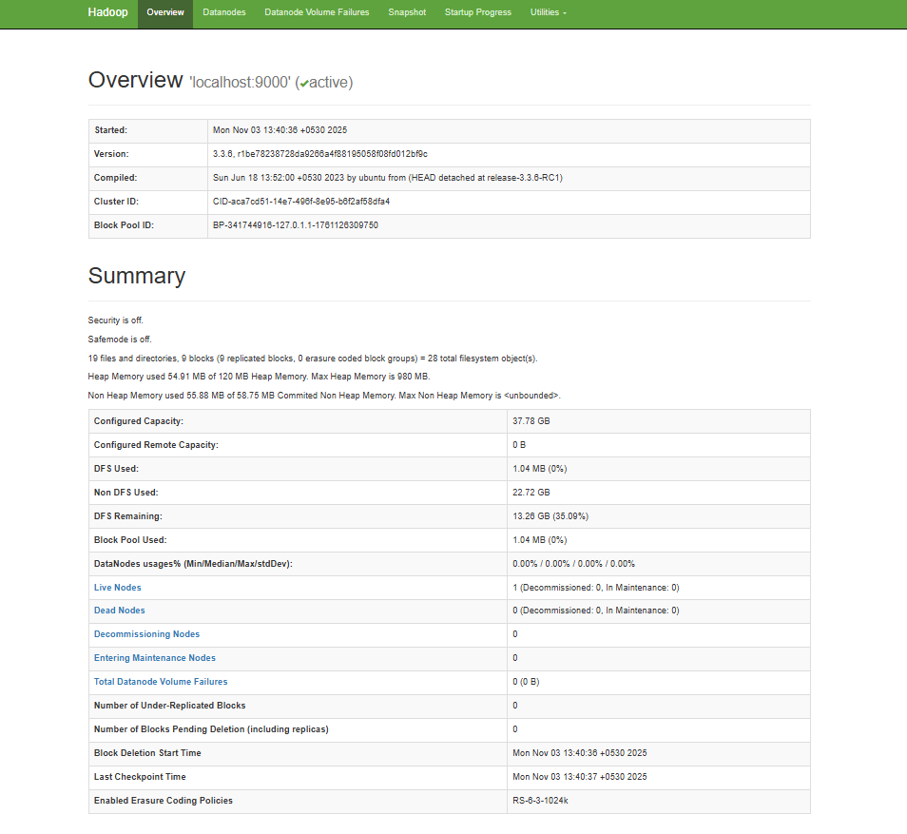

During Experiment
